

Program: ESE 4009

INSTRUCTOR: Prof. Mike Aleshams

Group# 7

Student Name | Student ID | Signature*
Amandeep Kaur | 748434 | Amandeep Kaur
Shweta Gulati | 747925 | Shweta Gulati

*By signing above you attest that you have contributed to this submission and confirm that all work you have contributed to this submission is your own work. Any suspicion of copying or plagiarism in this work will result in an investigation of Academic Misconduct and may result in a “0” on the work, an “F” in the course, or possibly more severe penalties.

Project Proposal

Project Title: IOT based Smart wearable safety gadget

Description of the latest similar system:
In the latest similar system there is a band which has an emergency button,and whenever a person feels unsafe,he or she can press the button.
If two conditions are met,first is that button is pressed and second is that the output value of pulse rate and ADXL sensors meet the threshold,then alrm buzzer starts working so that the people nearby get alerted and also an emergency message is sent along with location of the person to the preregistered contacts in GSM along with a ring.
Also if the output values of the sensors reach the threshold ,then also device is activated.
By using IOT platform ,the location of the person can be tracked.
Components used and their functioning:
- Raspberry Pi Zero -Here this microcontroller is used.It has storage of 1 GB.It is a small board,single core minicomputer.
- Pulse Rate Sensor -It senses the pulse rate.Normal pulse beat of a person is 80 to 90 beats per minute.And in critical situations it reaches to 110 to 120 beats per minute.So usually threshhold value is set to 120 beats per minute.
- ADXL Sensor – It is used to get the body posture of the person that the person is in fallen position or any other position.
- GPS Sensor – It finds the location of the person based on longitude and latitude values.The location is tracked by GPS and a link is created which is attached with message.
- GSM – It is a small chip and SIM card is inserted into it.Through this, a message and ring is sent to preregistered contacts.
- ADC – It is a 8 -bit convertor and requires5 V power supply.It converts analog values into digital values.
- Switch – It is connected to GPIO pin of Raspberry Pi.When one presses the switch,signal is sent to Raspberry Pi and it gets activated.
- Buzzer – In emergency situations,buzzer alerts the people nearby.
- Ubidots IOT Platform – It is used to track the live location of person.Location can be tracked by GPS device MAC address.

Limitations:
1. There is no way for capturing the culprit picture and store it on cloud. Because in such a case may contact person reach that place and before his/her arrival may attacker run.
2. There is no way to protect venerable by themselves despite monitoring and alerting.

Solution 1:
Block Diagram

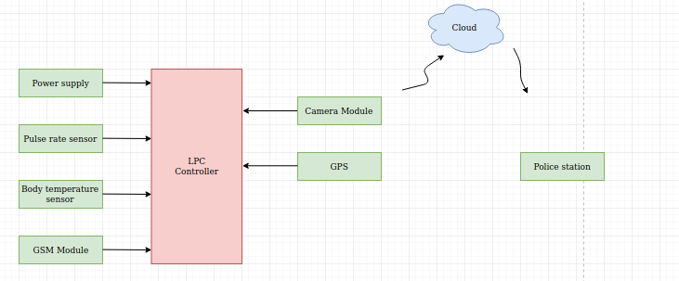

Feature

- The camera module will be added to take the images of the culprit, location, and situation. Then all the images are stored into the cloud so that police can use them for investigation purposes and can easily search a particular attacker by comparing his/her pictures with government records. Moreover, this system will make a call by GSM module to the required police number for instance 911 in Canada .

Hardware and Software Requirement:
Hardware platform:
- LPC 2148/LPC1769
- GSM module
- GPS
- Pulse rate sensor
- Body temperature sensor

Software platform : Micro vision Keil/Mcuxpresso

Reference: Chaudhari.A.,Patel.J., Savla.K.,Shetty.A., Shah.V.(2019).Women’s Safety Band Using IoT.lecture Notes on Data Engineering and Communications Technologies.

Solution 2:
Block Diagram

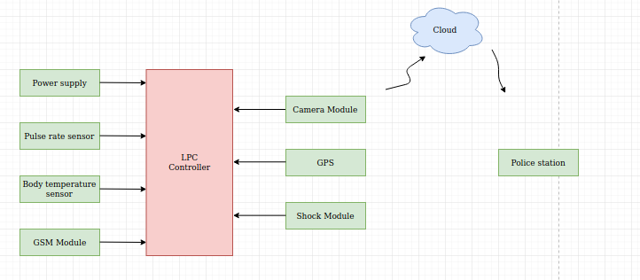

Feature
- The first preference for every person is to protect them by themselves. So, whenever a pulse sensor and temperature sensor gives values more than a threshold, then LPC transfer the required information for shock Module. In response, the Shocker module gives a shock to the attacker and in the meantime, the victim can run and protect themselves.

Hardware and Software Requirement
Hardware platform:
- LPC 2148/LPC1769
- GSM module
- GPS
- Pulse rate sensor
- Shocker Module
- Body temperature sensor
Software platform : Micro vision Keil/Mcuxpresso

Reference: Badli.S., Jathar.J., Tamble.T., Singhani.S.(2020).Women’s safety using IOT.International Reseach Journal of Engineering and Technology (IRJET).

Solution 3 :
- The existing system uses Raspberry pi whose cost is 84 whereas LPC is of 25 to 35 dollars. So, the system will become cost-effective.
- The weight of a system will be less. Therefore, it is easy to wear.

Reference: Tejonidhi.M.R.,Dyana. M.K.Aishwarya, Nagamma.H., Chaithara.K.S. (2019),IOT based smart secuirty gadget for women’s safety, International Conference on Advance in Information Technology.

